North Hamilton Member Resources

Administration Area

Members

Add Members

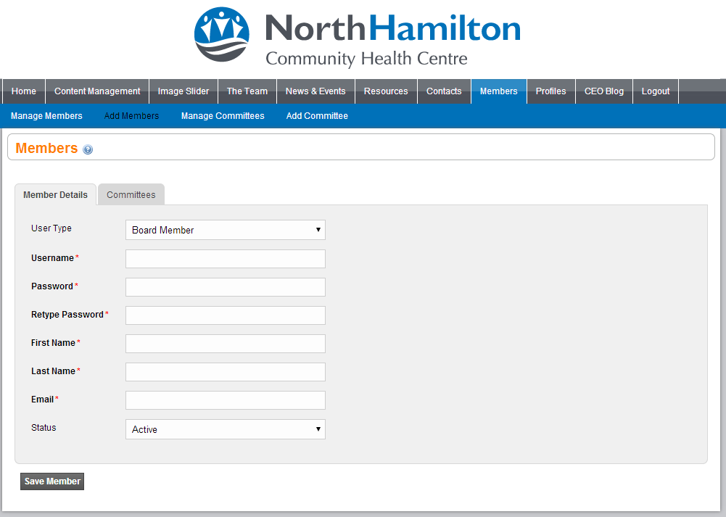

When adding a member only some basic information is required, a Username and Password which is required for signing into the Members area. The Users First and Last name, as well as a working email address so they are notified when new postings are created.
Currently in the system there are Four user types a user can be when setting up a new user which are the following; Board Member, Member, Volunteer, and Volunteer Coordinator.
- Board Members, have the ability to view all Board Member documents, all Committee Member Documents, as well as all Volunteer Documents; essentially they have access to any information that is posted into the entirety of the members’ resource area.
- Members, will only be able to view resources dependent on the committees that they are assigned (see image below), a member could belong to multiple committees if needed. To add them to the proper committee you would just check off the checkbox to the left of the committee name, and they will then be attached to that committee.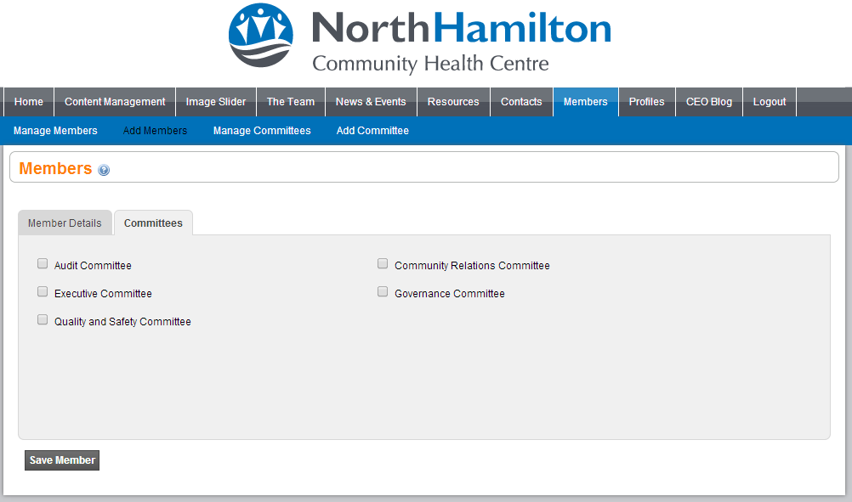
- Volunteers & Coordinators, both have the same role, the names are separated for distinction purposes for the administrator. They will only have access to files and Categories that are listed as volunteer categories when setting up resources.

Manage Members
This tab will provide you with a list of all the Board of Directors, Members, and Volunteers that have been setup in the system.
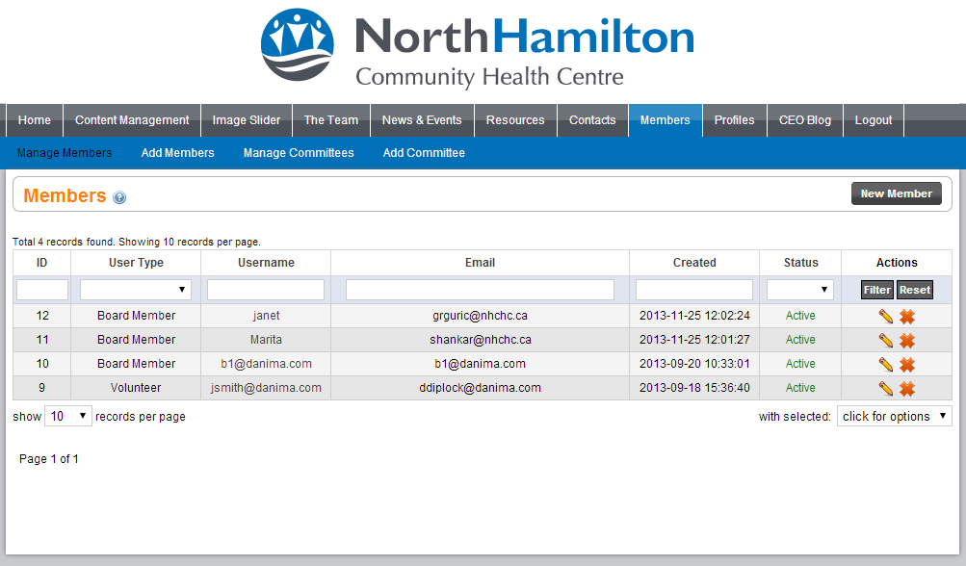
In the list of members you have the ability to search users so you can easily find a user that you may want to edit or remove completely from the system. This can be done with the search bar along the top of the list; as shown in the image below.
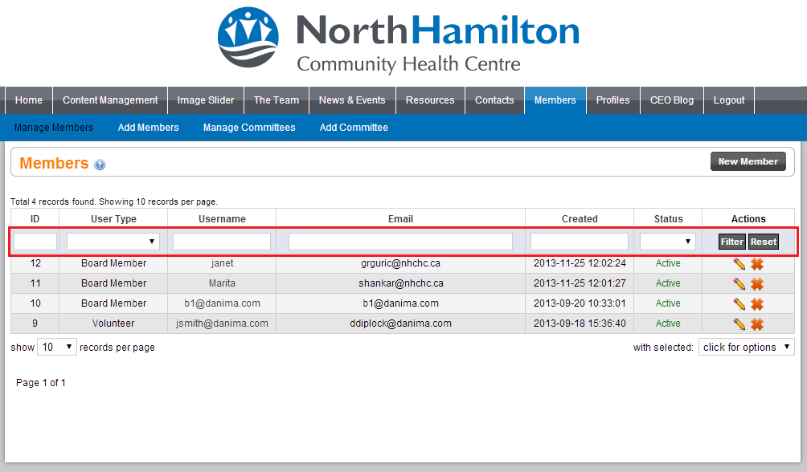
When you have typed in the username or email address you can click on the filter button under actions and it will only display the relevant information to the request. Using the image above as an example, if we searched “nhchc” in the email box and clicked filter, only two records would show, both ID 12 and 11.
Deleting a Member will remove the user from the system entirely; they will no longer be able to login via the front end either.
Editing a user is much like adding one, the only difference being you can add new committees to the user, or remove them, to changing their username and resetting their password.

Add Committee
Adding Committees is much like adding new Members to the system, only not as much information is required, you would give the committee a name and set whether the committee is active in inactive. You can also use the Resource Categories tab to easily select all the Categories you would like attached to this new Committee, opposed to going into each category and adding them one by one.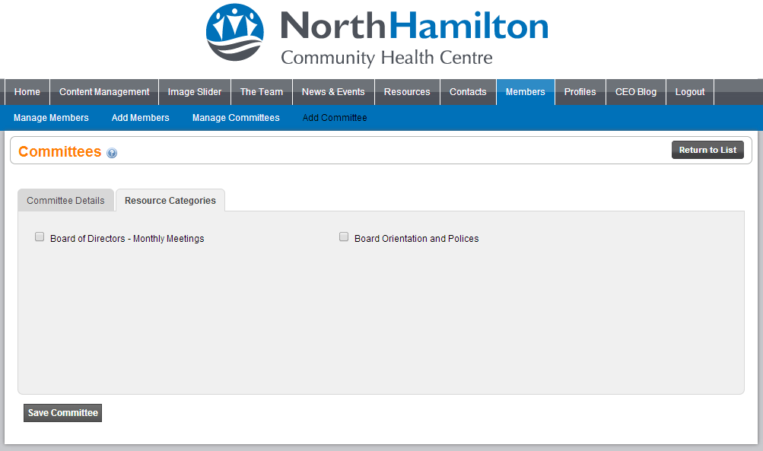

Manage Committees
Managing Committees, again much like managing the members you have the ability to filter, remove and edit the committees setting them inactive, or completely removing them from the system.

Resources

Add Category
Adding a Category allows you to categorize what your files will be going under, for example creating “Monthly Meetings”, you can then choose what committees the category belongs too.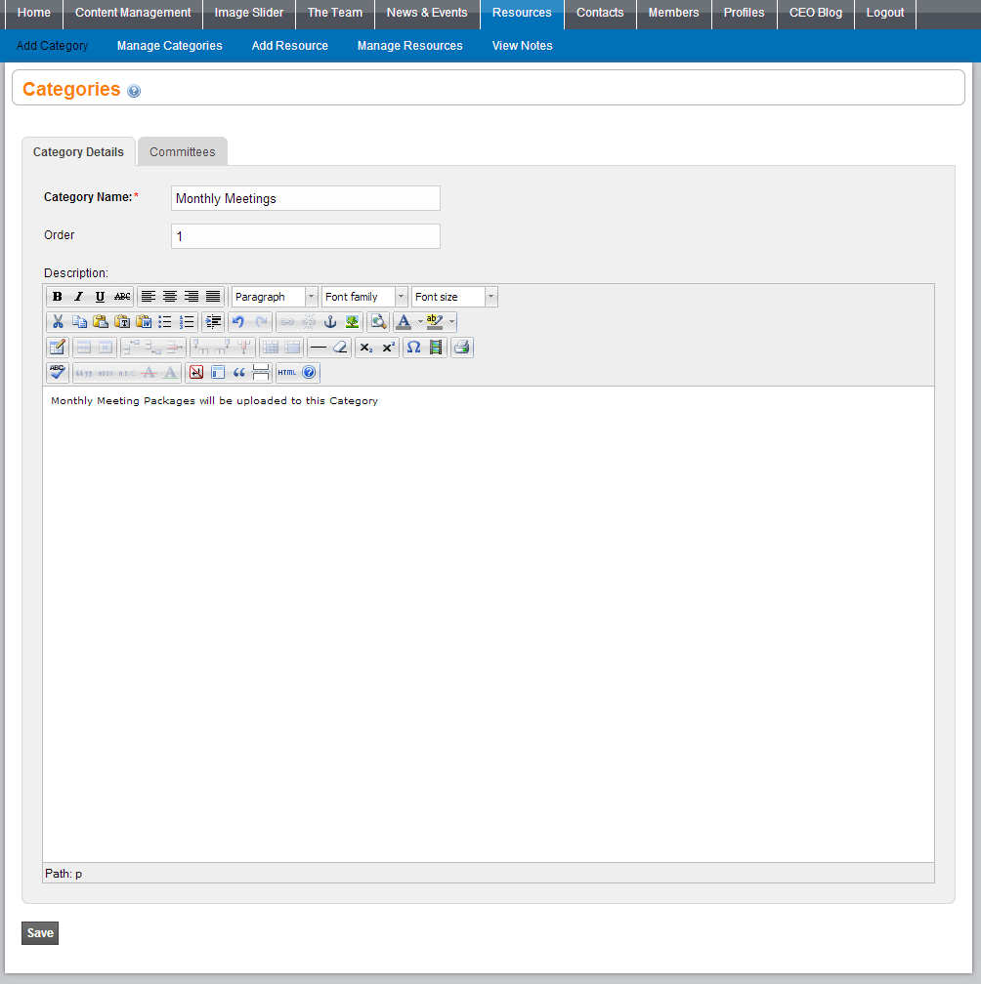
The committees that are selected below will affect what is displayed to the user on the front end, as well as where the Resources can be uploaded to, shown later in the “Add Resource” section.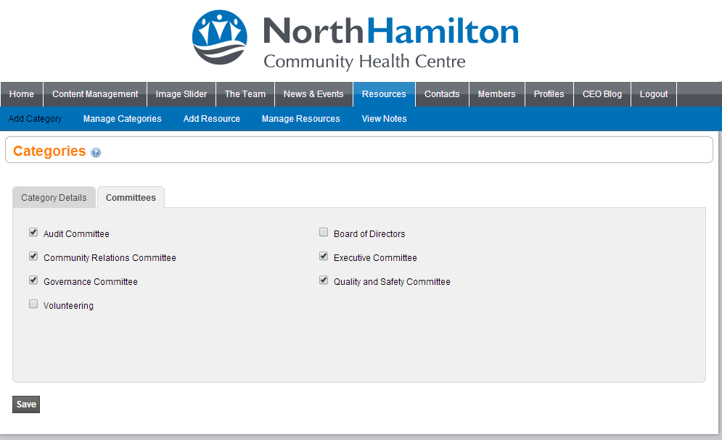

Manage Categories
The manage categories section, like the users will show a list of all the Categories that have been setup in the system, you can filter them, edit and remove them as well.

Add Resource
Adding resources can be thought of like adding a package of multiple documents under one unified name. For example, we want to create a document that only people in the “Auditing Committee” can view, called “January 2014”.
Checking off the “Send Email” button will then notify everybody in that committee that a new Package of multiple documents has been uploaded to their member area. The email body will also be used on the front end as the description the users will see for the resource.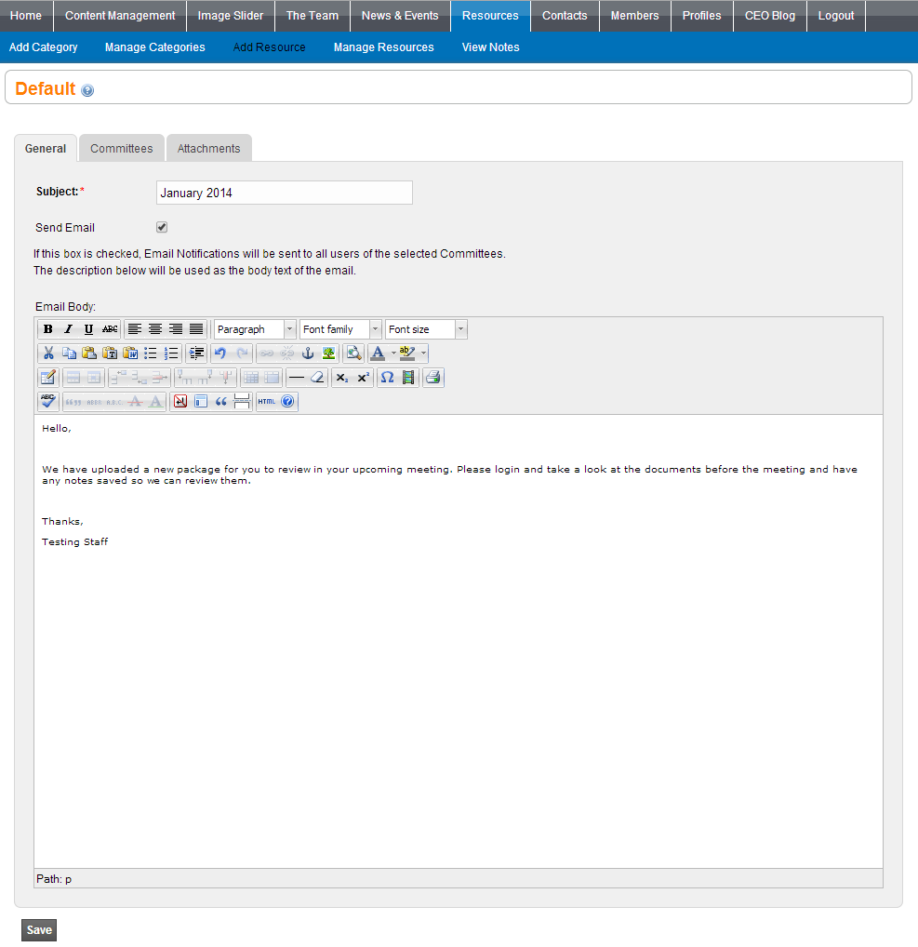
After getting all of the information inserted into the general tab you can select what committees this package will show up for by clicking into the committees tab. As you can see; even though we only created one “monthly meeting” category, and it is attached to multiple committees, it still treats them as separate entries.
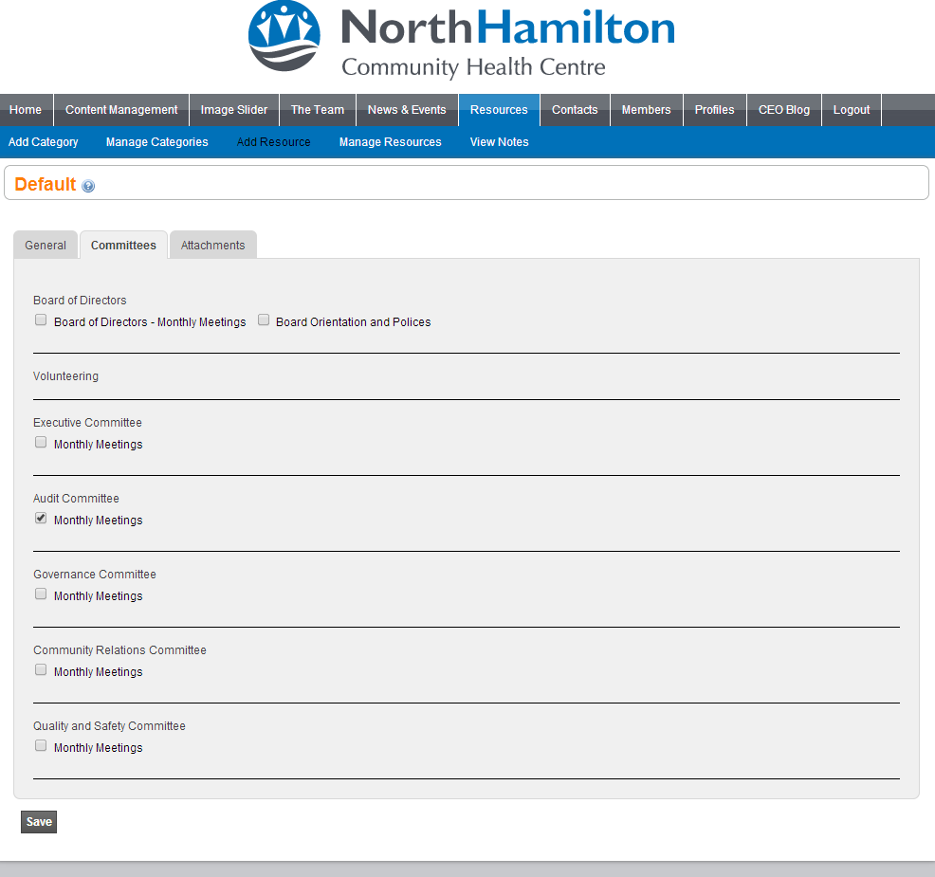
Once we have selected the Committees we want this Resource to be submit to we can start uploading the actual documents too it, which should be uploaded as PDF if possible. Too add multiple resources at one time you can click on the “[ + ] Add Another File” button in the top left hand corner.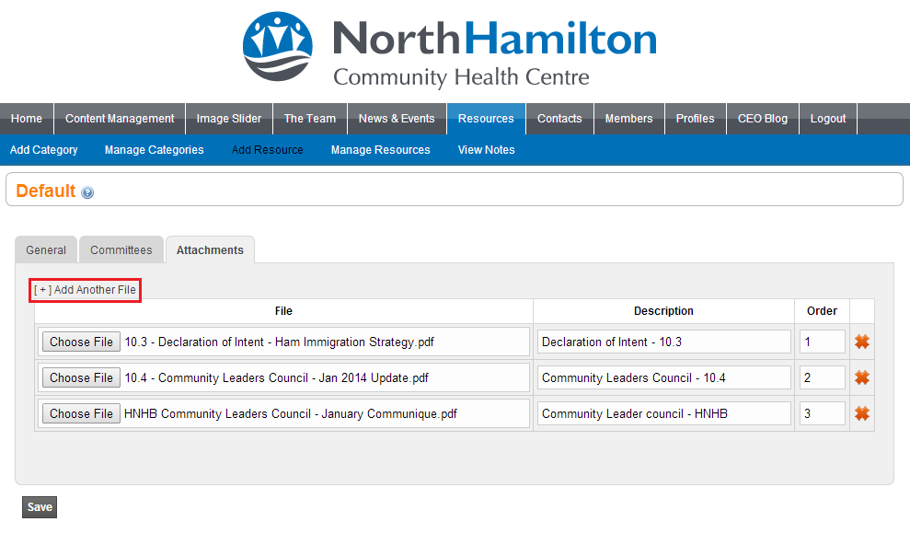
As shown in the above photo you can set Name Descriptors for the files that you upload so it is easy for the people logging into the front end to see what files they are opening, as well as inputting an Numerical Order which will be the order that the files are displayed on the front ( 0 – 255, whole numbers).

Manage Resources
Manage Resources allows you to Edit, and Delete the uploaded resources, but on top of this you can also view any shared Notes on the uploaded resources which can be used to better the system in general.

Front-End

General Information
When a user has logged in, they will have access to their profile information, notes they have posted onto documents, as well as the ability to log out from the system, that is all displayed in the top left hand corner of the screen.
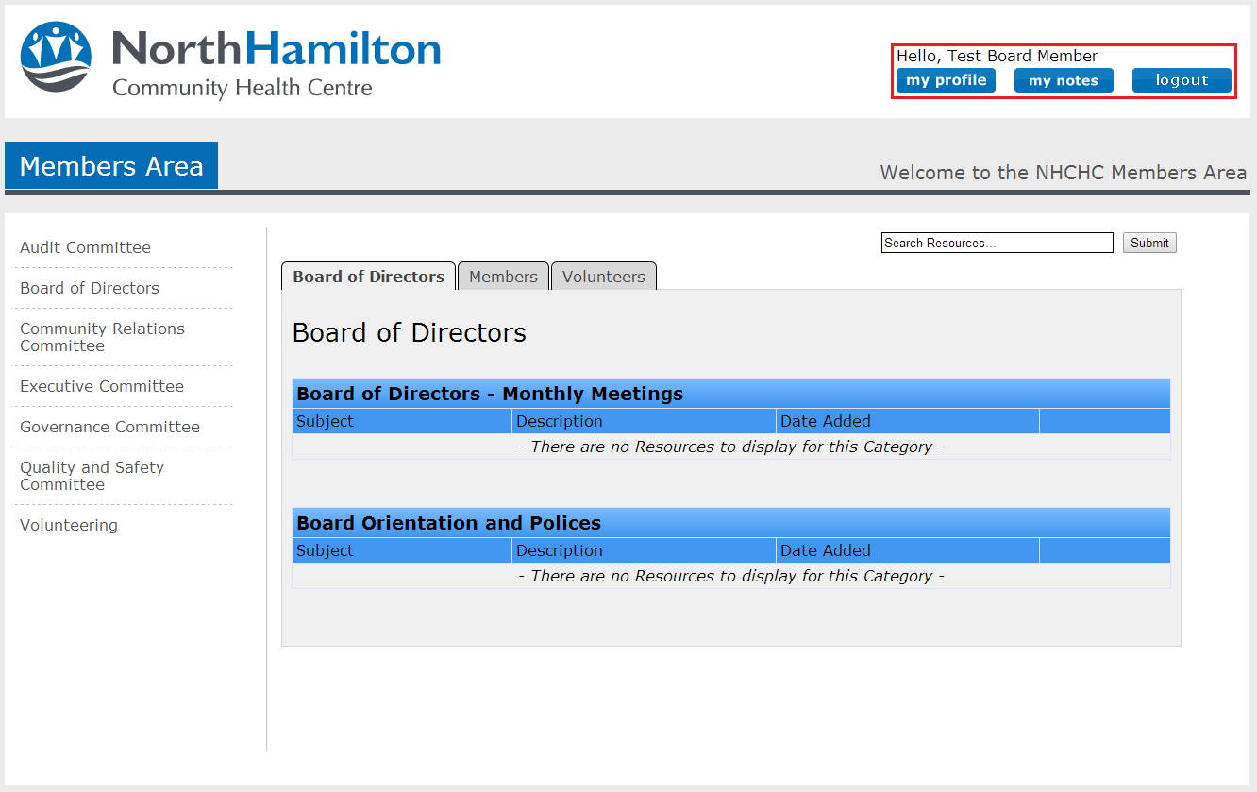
My Profile allows users who have logged in to change or correct their name, update their email address if it has changed, as well as reset their password if they want to change it from time to time.
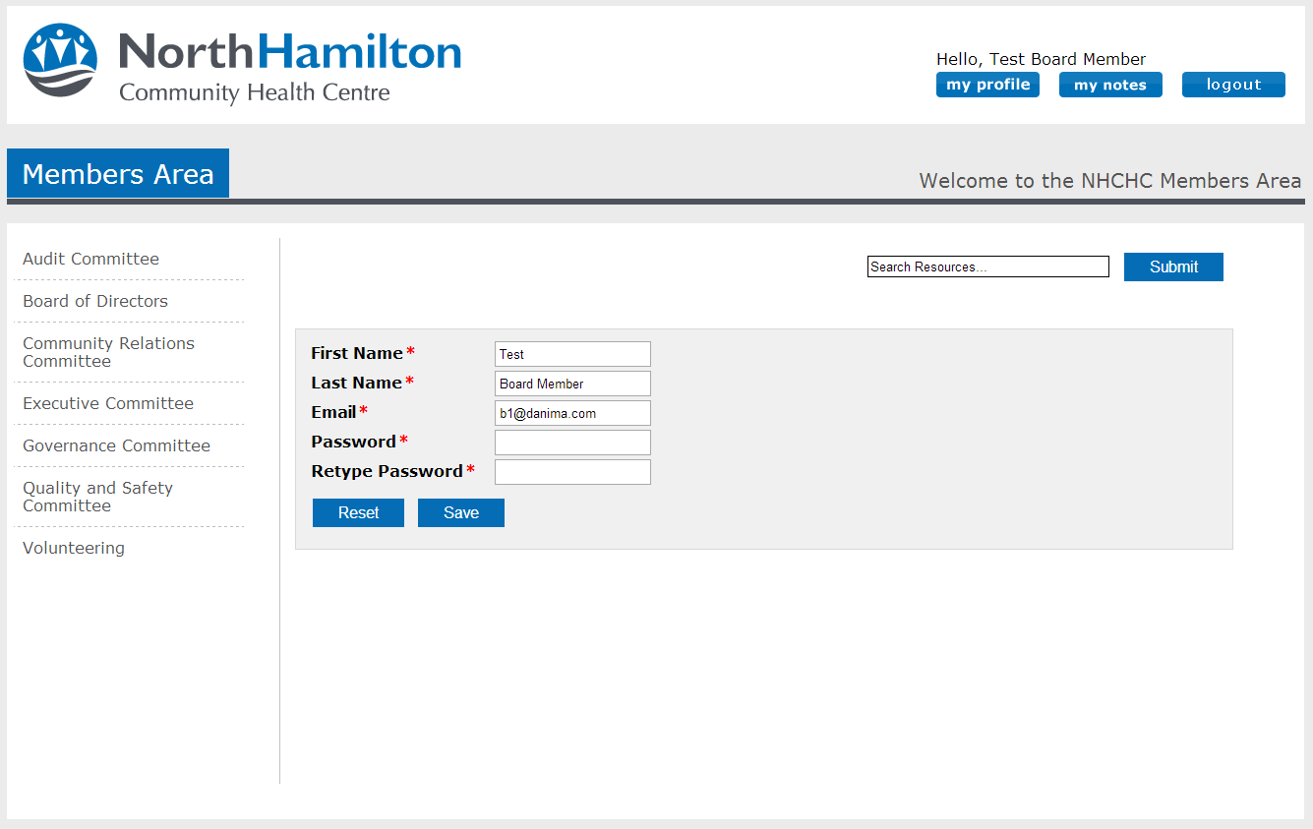

My Notes will list all the notes, along with the file that they applied the note too, they have the ability to go in and edit, as well as delete notes that they have created on files.

Board Member
When a board member logs in, they will have access to everything in the system, they can go into every committee on the left hand side, as well as their “Board of Directors”, and “Volunteering” Tabs so they can overlook all content being uploaded to the system. So if they click into the Auditing Committee for example, where we uploaded the resource. It will display like below.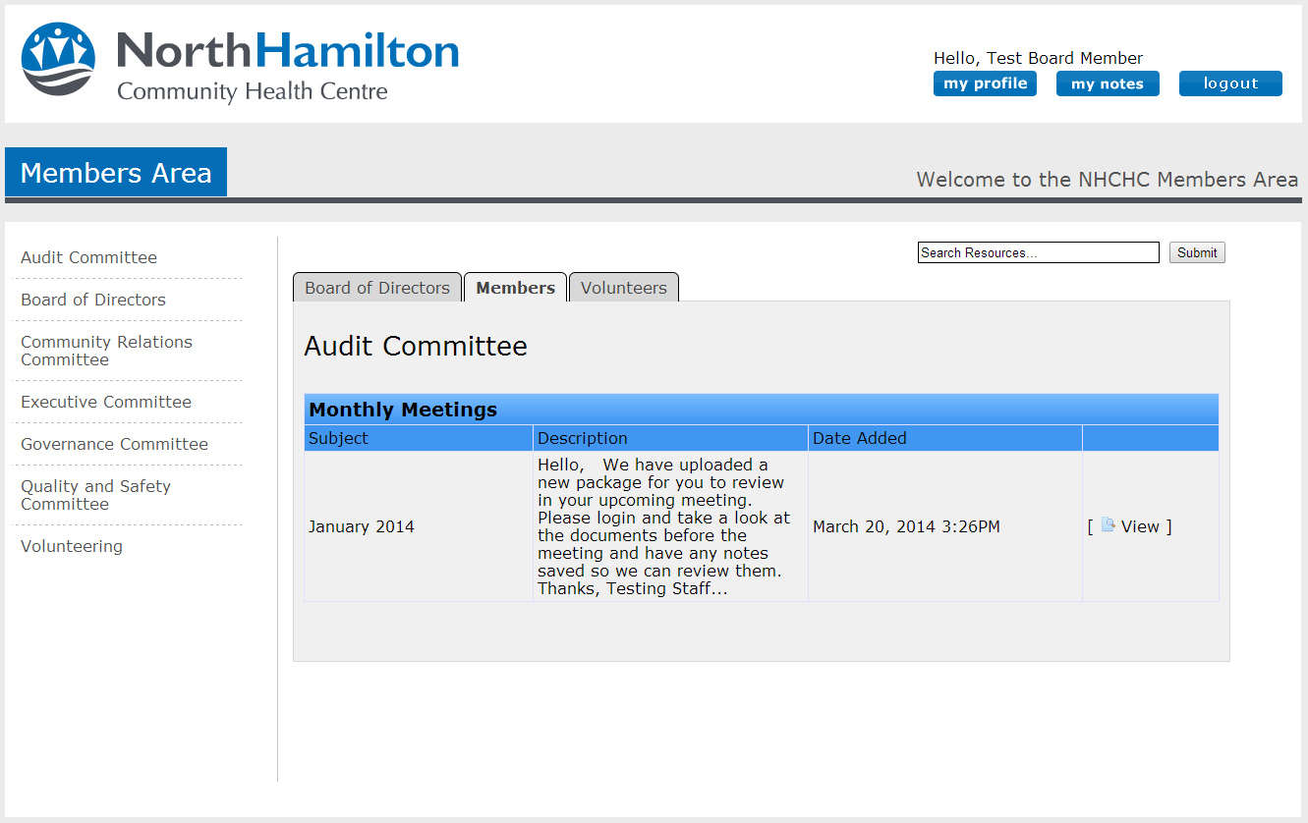
Now the Board of Director can click “View” on the on the “January 2014” Resource package to view all the files part of that package.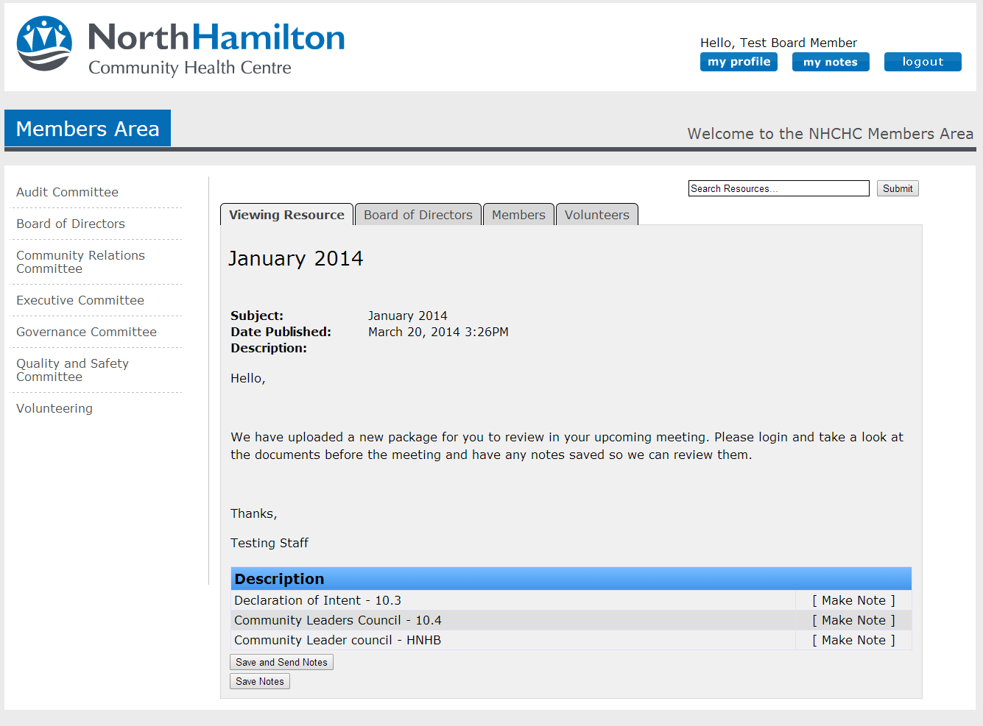
When viewing the Resource the user can then click the “Make Note” button, which will drop the file down, if it was uploaded as a PDF file it will automatically load on the left hand side, else the user will have to download it to their device, on the right the user can make notes, then Save the Notes or Save and Send the Notes.
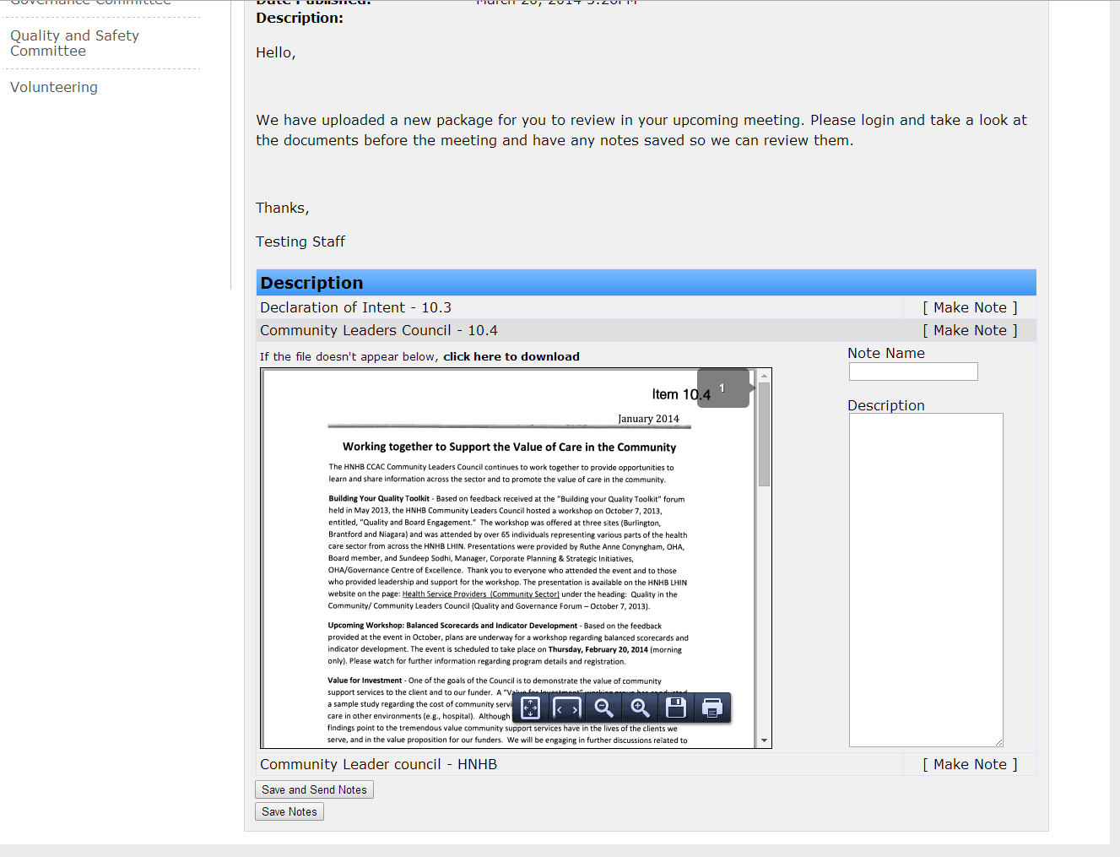
When the Notes are sent the Administrator will be able to view the notes in their administrative area.

Committee Member
When Committee Members login, they will only be able to see the Committee and the files that committee has attached to them, all other functionality is the same as the board member.
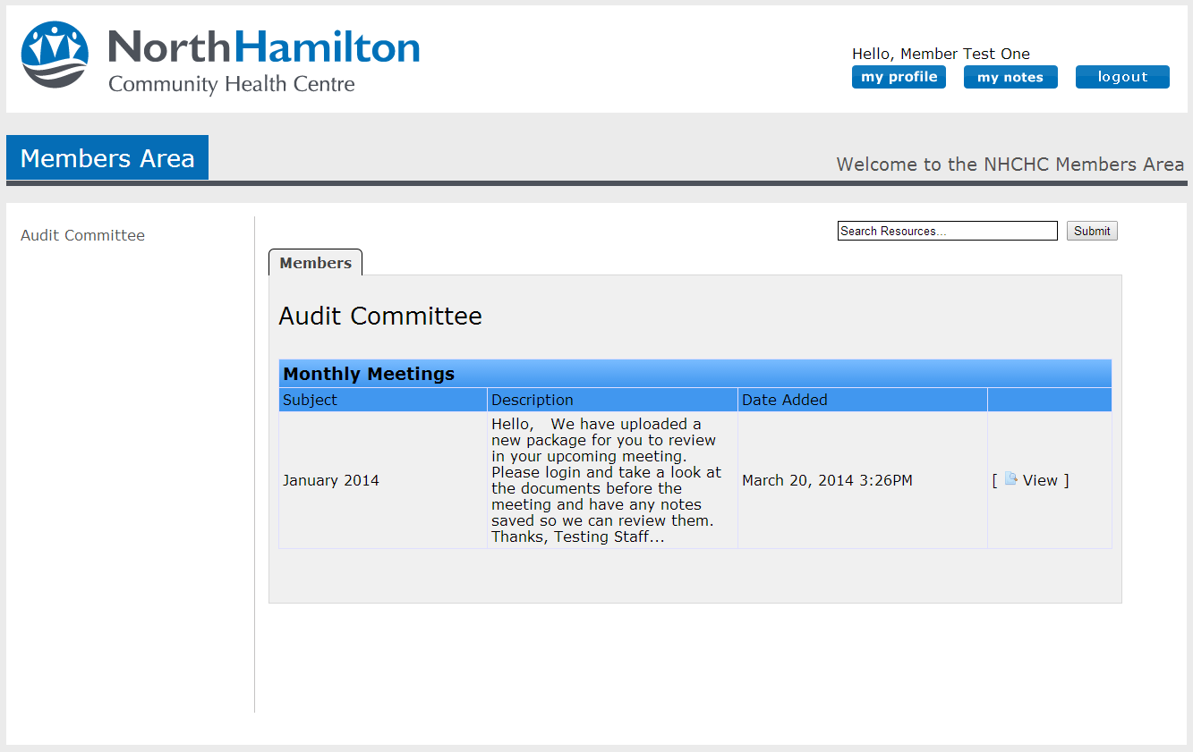

Volunteer
Also like the Committee member, but will only have accesses to the “Volunteering” Tab.

